**DAY 4**

1.     List all customers and the products they ordered with the order date. (Inner join)

select cust.company_name as customer, o.order_id, p.product_name,

od.quantity,o.order_date

from customers cust inner join orders o on cust.customer_id=o.customer_id

inner join order_details od on o.order_id=od.order_id

inner join products p on od.product_id=p.product_id order by 1,2;

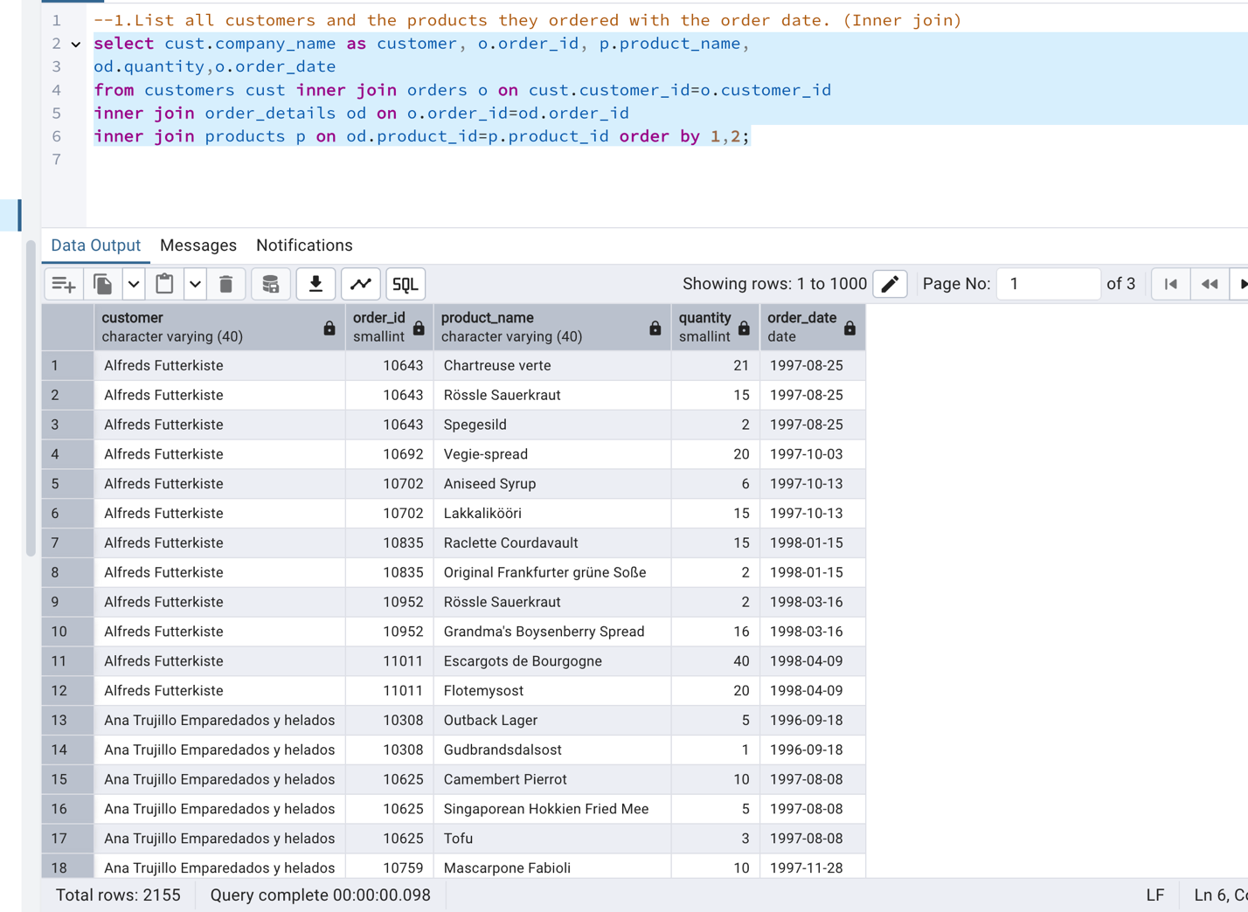

2.     Show each order with customer, employee, shipper, and product info — even if some parts are missing. (Left Join)

select o.order_id,o.customer_id,o.employee_id,o.order_date,o.shipped_date,

p.product_id,p.product_name from orders o

left join customers cust on o.customer_id=cust.customer_id

left join employees emp on emp.employee_id=o.employee_id

left join order_details od on od.order_id=o.order_id

left join products p on p.product_id=od.product_id

left join shippers sp on sp.shipper_id=p.supplier_id order by 1,2,3;

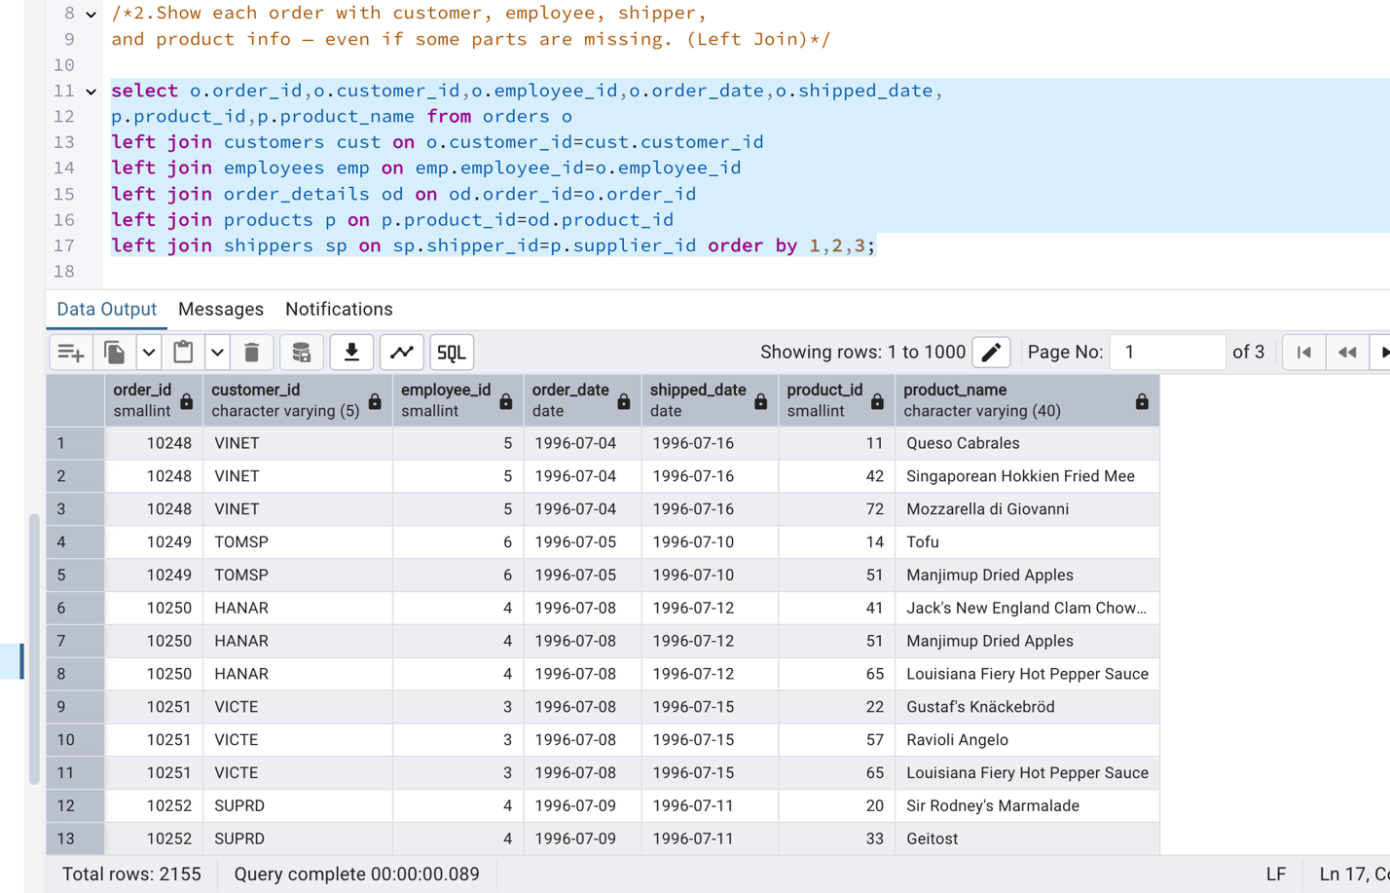

3.     Show all order details and products (include all products even if they were never ordered). (Right Join)

select od.order_id,p.product_id,od.quantity,p.product_name from order_details od

right join products p on od.product_id=p.product_id

order by 1;

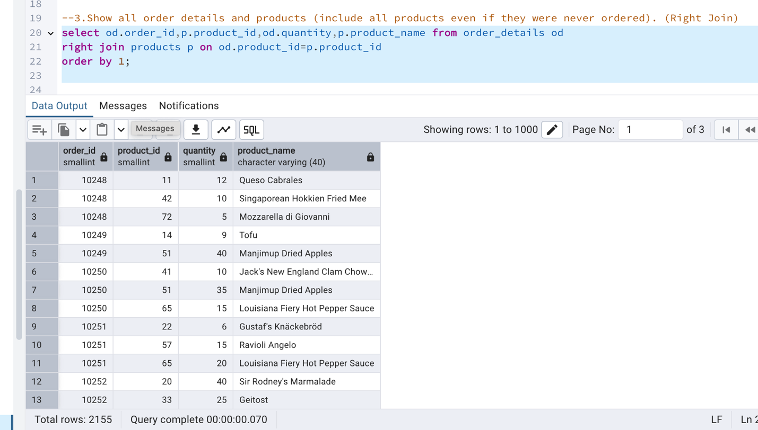

4. List all product categories and their products — including categories that have no products, and products that are not assigned to any category.(Outer Join)

select c.category_id,c.category_name,p.product_id,p.product_name

from categories c

full outer join products p on c.category_id=p.category_id;

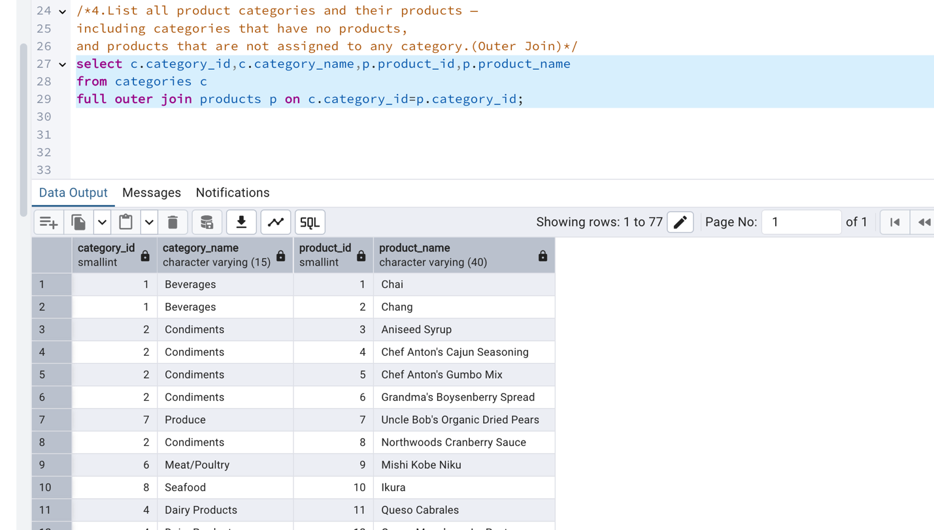

5. Show all possible product and category combinations (Cross join).

select p.product_name,c.category_name

from products p cross join categories c ;

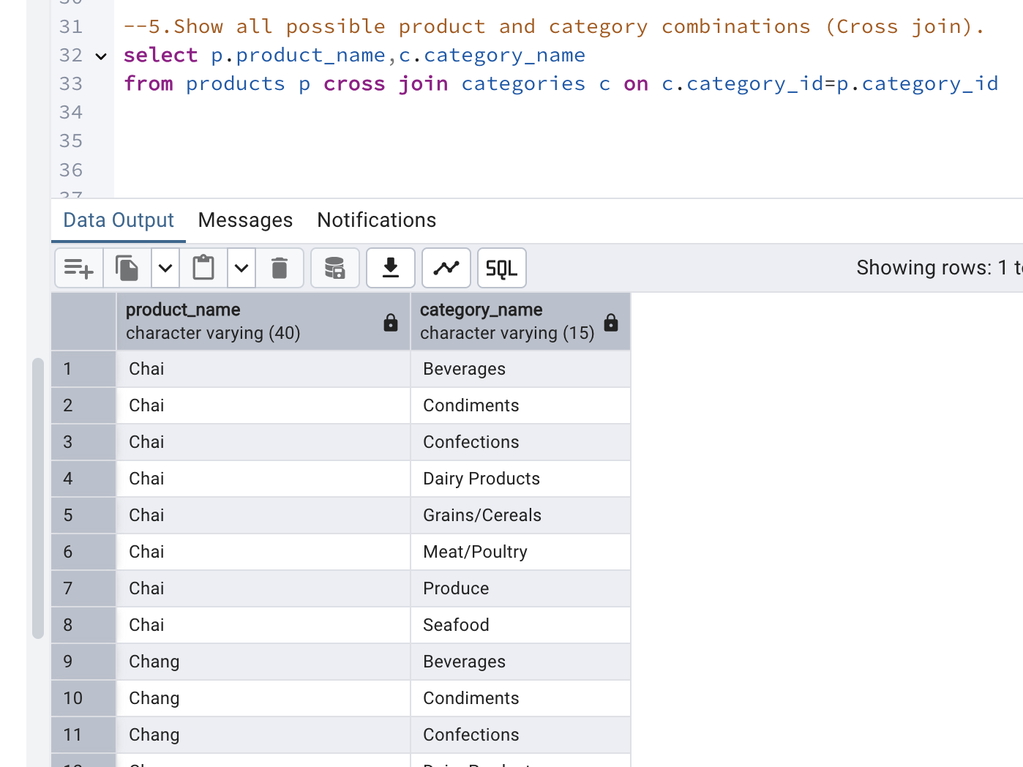

6. Show all employees and their manager(Self join(left join))

select e.first_name||' '||e.last_name as employee_name,

m.first_name||' '||m.last_name as manager_name

from employees e

left join employees m on e.reports_to=m.employee_id;

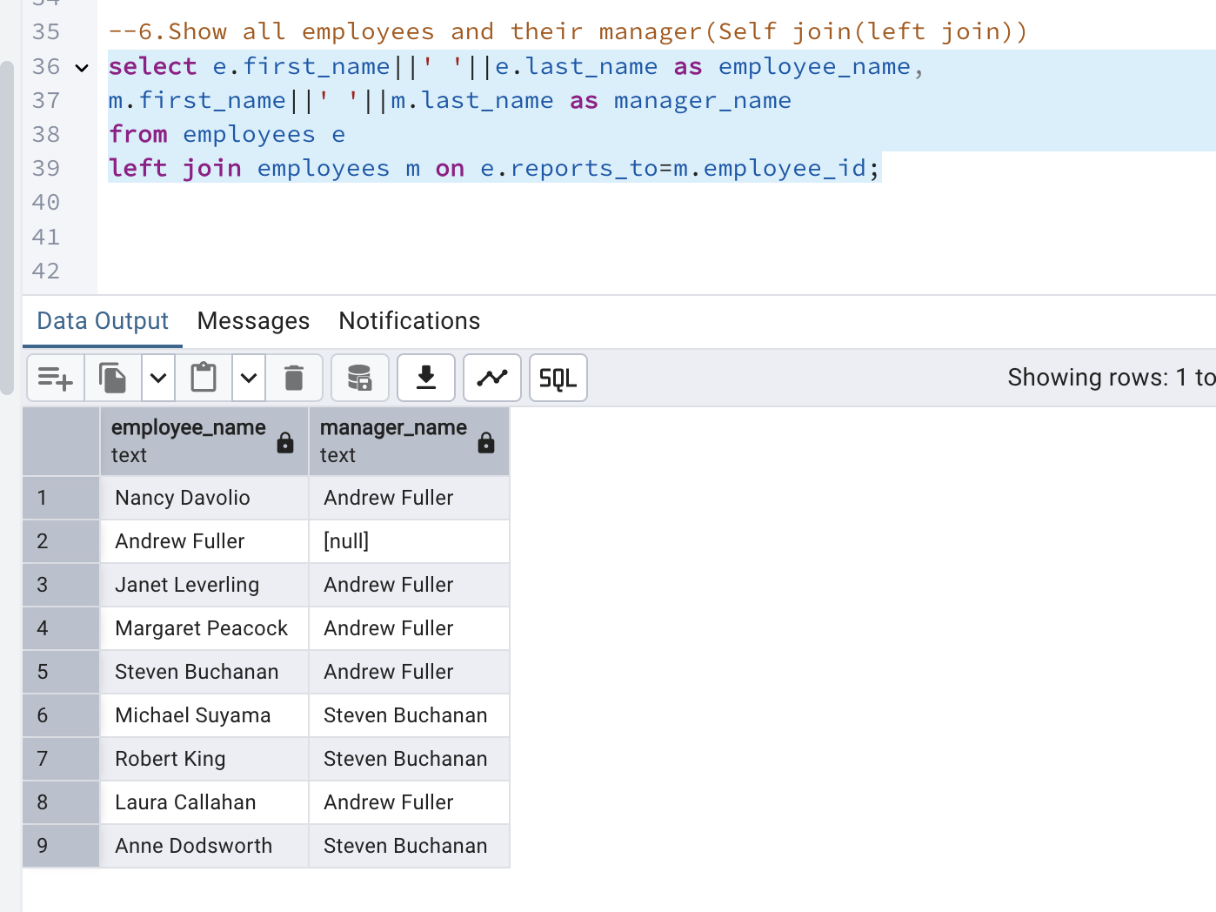

7. List all customers who have not selected a shipping method.

select c.customer_id,c.company_name,o.order_id

from customers c left join orders o

on c.customer_id=o.customer_id

where o.ship_via is null;

